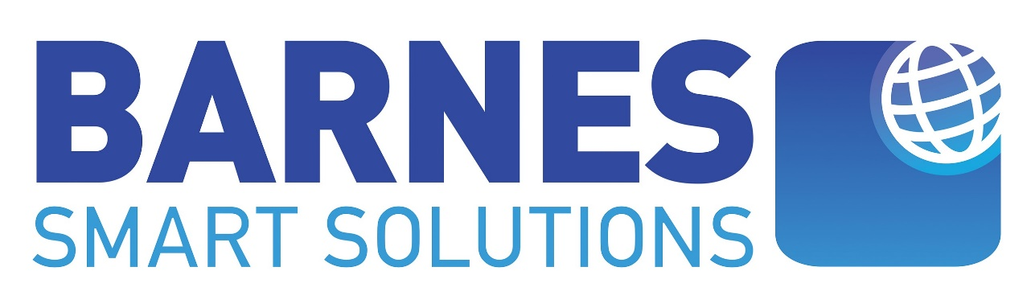

Remote Work Revolution: A New Era of Productivity and Flexibility
The traditional 9-to-5, office-bound workday is rapidly becoming a relic of the past. Remote work, once a fringe concept, has now become a mainstream reality, reshaping the way we work and live. With advancements in technology and a growing globalised economy, remote work has emerged as a powerful tool for businesses and employees alike. This blog post will explore the myriad benefits of remote work, the challenges it presents, and strategies for overcoming these obstacles, ultimately highlighting how this shift can lead to a more productive and flexible future.

The Benefits of Remote Working
Remote work offers a myriad of advantages for both employees and employers.
Benefits for Employees
- Increased Flexibility: Remote workers enjoy the freedom to set their own schedules, allowing for a more personalised work-life balance. This flexibility enables individuals to manage personal commitments alongside professional responsibilities effectively.
- Reduced Stress: The elimination of daily commuting reduces stress levels associated with traffic and public transport. Additionally, the absence of office politics contributes to a more relaxed and productive work environment.
- Improved Work-Life Balance: Remote work fosters better integration of personal and professional life, allowing employees to allocate time for family, hobbies, and self-care without compromising their job performance.
- Enhanced Creativity: Working remotely can stimulate creativity and innovation by exposing individuals to diverse perspectives and experiences. This environment encourages out-of-the-box thinking, leading to fresh ideas and solutions.
Benefits for Employers
- Increased Productivity: Studies have shown that remote workers are often more productive than their office-bound counterparts. The autonomy to create an optimal workspace leads to fewer distractions and enhanced focus on tasks.
- Reduced Overhead Costs: By minimising the need for physical office space and related expenses (utilities, maintenance), businesses can significantly cut costs. This financial flexibility allows companies to allocate resources more efficiently.
- Access to a Wider Talent Pool: Remote work enables companies to hire the best talent from anywhere in the world, breaking geographical barriers that previously limited recruitment efforts. This diversity fosters innovation and collaboration within teams.
- Improved Employee Morale: Offering remote work options can lead to higher employee satisfaction and retention rates. Employees who feel trusted to manage their own schedules are often more engaged and committed to their work.

The Challenges of Remote Working
Despite its numerous benefits, remote working also presents several challenges:
- Isolation: Remote workers may experience feelings of isolation and disconnection from their colleagues, which can impact morale and collaboration.
- Lack of Structure: Without a traditional office environment, maintaining a consistent work routine can be challenging. This lack of structure may lead to procrastination or decreased productivity.
- Technical Difficulties: Reliable internet connectivity and robust technical support are essential for successful remote work. Any disruptions can hinder productivity and communication.
- Security Concerns: Protecting sensitive company data while working remotely poses significant challenges. Organisations must implement strong cybersecurity measures to safeguard information.

Overcoming the Challenges
To mitigate these challenges, remote workers and employers can implement effective strategies:
- Regular Communication: Consistent communication through video conferencing, instant messaging, and emails is crucial for maintaining team cohesion and ensuring everyone is aligned on goals.
- Virtual Team Building: Organizing virtual team-building activities helps foster camaraderie among remote employees. These initiatives can enhance relationships and create a sense of belonging within the team.
- Clear Expectations: Setting clear expectations regarding roles, responsibilities, and deadlines helps remote workers stay focused and productive. Regular check-ins can reinforce accountability.
- Enhanced Security Measures: Implementing improved multi-factor authentication systems and regular cybersecurity training ensures that employees are equipped to handle sensitive information securely while working remotely.

The Future of Remote Working
As technology continues to advance, the future of remote work looks promising. More companies are embracing remote work as a long-term strategy rather than a temporary solution. By addressing challenges head-on and maximising the benefits of remote work arrangements, organisations can revolutionise how we work and live.

Barnes Smart Solutions: Your Partner in Remote Work Success
Barnes Smart Solutions is dedicated to helping businesses and individuals transition successfully into a remote work environment. With our expertise in technology integration and strategic planning, we can assist you in ensuring that your remote workforce is not only productive but also secure.
With the help of our Partners at Monet+, ProID, a modular platform designed to enhance work success by focusing on workforce and technical Identity management
How ProID support Businesses and Employees in Navigating the Complexities of Remote Work:
- Enhanced Security: ProID provides robust security for managing digital identities, reducing the risk of data breaches and unauthorised access, already implemented for over 170 000 users.
- Streamline Access Management: The platform simplifies granting and revoking access to tools and resources, ensuring employees have what they need without compromising security.
- Flexible Identity Solutions: ProID’s modular designs organisations to tailored identity management solutions to meet specific needs, accommodating diverse teams across various locations.
- Support for Remote Collaboration: With features that facilitate secure communication and collaboration, ProID enhances productivity while protecting sensitive information.
- Compliance and Audit Readiness: ProID provides detailed autid trails of user activities, helping organisations maintain compliance with industry regulations and build trust with stakeholders.

By integrating ProID into remote work strategy, businesses can not only safeguard their digital assets but also empower their employees to work efficiently and securely from anywhere. This partnership with Monet+ positions Barnes Smart Solutions as a leader in facilitating successful remote work environments, paving the way for enhanced productivity and flexibility in the modern workplace. Embrace this new era with Barnes Smart Solutions as your trusted partner in navigating the evolving landscape of remote work.

